



ITALIA - Lignano Sabbiadoro - Udine

27th ➢ 30th April 2006

MEDITERRANEAN CUP

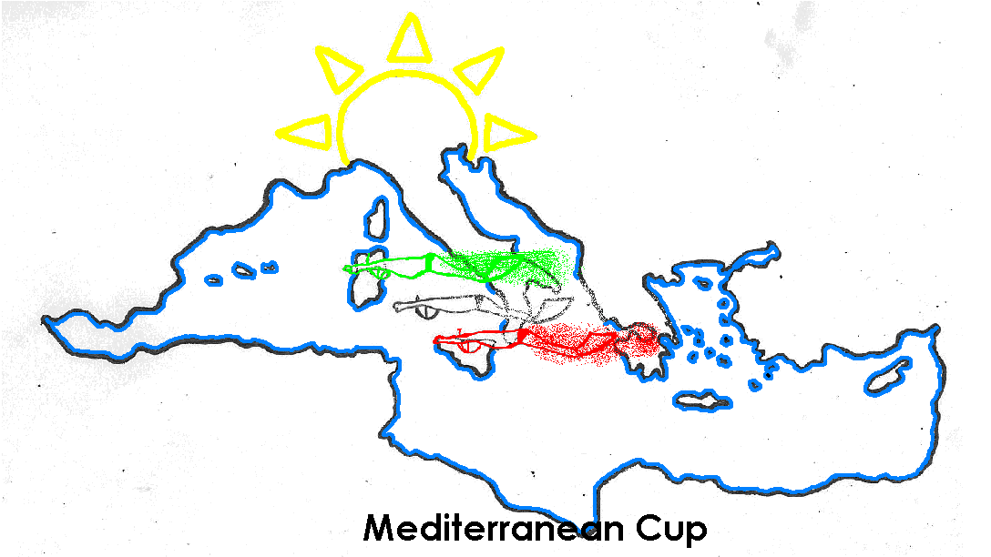
in FINSWIMMING

Dear C.M.A.S. Member Federation,
The Italian Federation F.I.P.S.A.S. and the Organizing Committee has the pleasure to invite you and your finswimming team to participate in the
3rd edition of the MEDITERRANEAN CUP IN FINSWIMMING,
to be held in Lignano Sabbiadoro (Udine) from 28th to 30th of April 2006.

GENERAL CONDITIONS
- “3° MEDITERRANEAN CUP in Finswimming” is open to all teams of the National Federations who are associated with CMAS, under the rules of the CMAS.
- CMAS International Sport License for all swimmers.
- Result will be compiled according to C.M.A.S. score point.
- Two swimmers in each distance for each team.
- Out of race. Every team can enrolled more athletes in each distance out of race (for test, no point, no medal, no final) a special classification will be prepared.

IMPORTANT DATES TO NOTE:
- A) Initial entry form: 28th February 2006
- B) Residence Ge. Tur booking form & Fees : 6th March 2006
- C) Final entry form : 15th April 2006

SWIMMING-POOL:
Indoor Olympic swimming-pool length 50 meters, 8 lanes, depth m. 2.00/2.50, Omega electronic scoreboard and timekeepers, about 1.000 spectator seat. The swimming-pool is inside the area of the Residence Ge. Tur.

ACCOMMODATION:
The official accommodation (Residence Ge. Tur in Lignano Sabbiadoro), from the afternoon of Thursday 27th April 2006 to the morning of Monday 1st May 2006.

TRANSPORT:
No transport are allowed. Rent a bus or transport will be organized at your request. The price for this transport is not included in the participation fees.

NATIONAL FLAGS:
We kindly ask each delegation to bring with them n. 2 National Flag (1m. x 2m.) and Anthem (CD).

RULES:
C.M.A.S. FINSWIMMING INTERNATIONAL RULES.

For further information:
F.I.P.S.A.S. Federazione Italiana Pesca Sportiva ed Attività Subacquee
Settore Nuoto Pinnato
Viale Tiziano, 70
00196 ROMA (Italy)
Telephone: (+39) 06-3685.8290
Fax: (+39) 06-3685.8109
E-mail: nuotopinnato@fipsas.it
Web site: www.fipsas.it / www.nuotopinnato.it

Best Regards
Ugo Claudio MATTEOLI
FIPSAS President

ACCOMMODATION AND RESIDENCE Ge. Tur BOOKING

ACCOMMODATION
Total cost includes entry fees and hotel accommodation in three stars hotels.
Residence Ge. Tur | single | Double/triple
 | Euro 320,00 | Euro 250,00 | Per person / 4 nights
Total cost covers:
- Residence Ge. Tur accommodation on full board basis (B/L/D), starts from dinner 27/04/2006 till breakfast 01/05/2006.
- Participation Fees, Opening, Closing and Awards ceremonies.
- Bottles refilled
- Payment should be received not later than 9th March 2006

In case of payment after 9th March 2005, the cost will be:
Residence Ge. Tur | Single | Double/triple
 | Euro 360,00 | Euro 310,00 | Per person / 4 nights

Cost of extra days (to be indicated in advance):
Residence Ge. Tur | single | double/triple
 | Euro 65,00 | Euro 45,00 | Per person / Per nights
The cost covers:
- Residence Ge. Tur accommodation on full board basis (B/L/D).

Payment:
a) Payment is accepted by bank transfer to:
UNICREDIT BANCA
Named: Centro Nuoto Pinnato Roma
IBAN Code: IT 48 H 02008 03335 000020099659

b) Cash on Arrival.

INITIAL ENTRY FORM
before 28th February 2006
We will participate in the “3rd MEDITERRANEAN CUP in Finswimming 2006” in Lignano Sabbiadoro.
A- Initial Entry Form:
Please complete this form (type or print) and send by fax (+39.06.3685.8109) or e-mail (nuotopinnato@fipsas.it) to the Organizing Committee before 28th February 2006.

Country

Federation

Total No. of Competitors | Male |  | Female

Total No. of Officials | Male |  | Female

Total number of the delegation | N.

Declaration Form:
Release from liability: I hereby declare that I exonerate of all liability however so arising, the CMAS, its affiliates, the event Organizing Committee and staff, the venue owners, sponsors, and any other persons that participate at the Event, in respect to all and every action or claim about accidents that may occur.

Date, ________________________

______________________ ___________________________
(Signature/ stamp) (Full name in block letters)

Residence Ge. Tur BOOKING FORM
before 6th March 2006

B- Residence Ge. Tur Booking Form:
Please complete this form (type or print) and send by fax (+39.06.3685.8109) or e-mail (nuotopinnato@fipsas.it) to the Organizing Committee before 6th March 2006.

Country

Federation

Telephone

Fax |  | e-mail

Please complete:
Residence Ge. Tur
 | Number of Rooms | Date
 | Number of Rooms | From | To
Single
Double/Triple

Extra Nights:
If you need extra nights, please fill in the following:
 | Number of Rooms | Date
 | Number of Rooms | From | To
Single
Double/Triple

Method of Payment:
Please check (x) in one of the following:
a) Bank Transfer | □ | Date of transfer :
b) Cash on Arrival | □

Date, ________________________

______________________ ___________________________
(Signature/ stamp) (Full name in block letters)

FINAL ENTRY FORM
before 15th April 2006
Out of race: If you want enrolled more than two athletes in each distance, you have to complete two different documents. One for official and one for out of race (test)
C- Final Entry Form:
Please complete this form (type or print) and send by fax (+39.06.3685.8109) / e-mail nuotopinnato@fipsas.it

Country

Federation

Telephone

Fax |  | e-mail

Max Two (2) swimmer in each distance.
Surname | Name | Sex | Birth | 50sf | 100sf | 200sf | 400sf | 800sf | 1500sf | 50ap | 100im | 400im | 800im

Write the time of the relay | Time | 1st Athlete Name | 2nd Athlete Name | 3rd Athlete Name | 4th Athlete Name
Relay 4x100 sf Women
Relay 4x200 sf Women
Relay 4x100 sf Men
Relay 4x200 sf Men
NB: In the Relay, the order of the athletes will be change until the day before the competition.

Head of Delegation |  | Trainer
Trainer |  | International Judge
Doctor |  | Physiotherapist
Others

Date_________ _________________ ______________________
(Signature/ stamp) (Full name in block letters)

OFFICIAL PROGRAMME

- Thursday 27th April 2006
  - Afternoon: - Arrival and Residence Ge. Tur check–in
  - Afternoon: - Training at the swimming-pool
      - - Checking documents
      - - Checking equipment
  - 19.00 - Technical meeting at the swimming-pool

- Friday 28th April 2006
  - 08:30 – 09:30 - Warm-up
  - 09.45 - Opening Ceremony
  - 10.00 - m. 100 surface Women/Men (qualifying heats)
- m. 1.500 surface Women/Men (slow heats)
- m. 400 immersion Women/Men (slow heats)
- relay 4x200 surface Women/Men (slow heats)
- lunch at the hotel
  - 16:00 – 16:50 - Warm-up
  - 17.00 - m. 100 surface Women/Men (FINAL)
- m. 1.500 surface Women/Men (LAST HEAT)
- m. 400 immersion Women/Men (LAST HEAT)
- relay 4x200 surface Women/Men (LAST HEAT)

- Saturday 29th April 2006
  - 08:50 – 09:50 - Warm-up
  - 10.00 - m. 50 surface Women/Men (qualifying heats)
- m. 800 immersion Women/Men (slow heats)
- m. 400 surface Women/Men (slow heats)
- m. 100 immersion Women/Men (slow heats)
- lunch at the hotel
  - 16:00 – 16:50 - Warm-up
  - 17.00 - m. 50 surface Women/Men (FINAL)
- m. 800 immersion Women/Men (LAST HEAT)
- m. 400 surface Women/Men (LAST HEAT)
- m. 100 immersion Women/Men (LAST HEAT)

- Sunday 30th April 2006
  - 08:50 – 09:50 - Warm-up
  - 10.00 - m. 50 apnoea Women/Men (qualifying heats)
- m. 200 surface Women/Men (qualifying heats)
- m. 800 surface Women/Men (slow heats)
- relay 4x100 surface Women/Men (slow heats)
- lunch at the hotel
  - 16:00 – 16:50 - Warm-up
  - 17.00 - m. 50 apnoea Women/Men (FINAL)
- m. 200 surface Women/Men (FINAL)
- m. 800 surface Women/Men (LAST HEAT)
- relay 4x100 surface Women/Men (LAST HEAT)
- Closing Ceremony

- Monday 1st May 2006
  - Morning - Residence Ge. Tur check-out and departure

