12. TIME TABLE

Friday 4.2.2005
from arrival to 19,00 verification (payment for accommodation and starting fee registration, last changing of the registrations - departure only)

19,00 - meeting of the team leaders - conference room in the pensions
- dinner
20,00 - 22,00 possibility of training
Saturday 5.2.2005
6,30 - 8,00 breakfast
8,00 warm up
8,45 Opening ceremony
9,00 400m FS men
10,00 400m FS women
10,45 50m AP men
11,15 50m AP women
11,45 award ceremony
12,00 200 m FS men

time for lunch

14,15 warm up
15,00 200m FS women
15,45 100m IM men
16,30 100m IM women
17,15 award ceremony
17,30 4 x 100m men
4 x 100m women
19,00 dinner
20,00 dinner for team leaders, assembly at 19,30 before the pension
Sunday 6.2.2005
6,30 - 8,00 breakfast
8,00 warm up
8,45 400m IM women
9,45 400m IM men
10,15 100m FS women
11,00 100m FS men
11,45 award ceremony
12,00 4 x 200m women
4 X 200m men
13,00 award ceremony & closing ceremony
14,00 lunch and leaving the rooms till 15,00


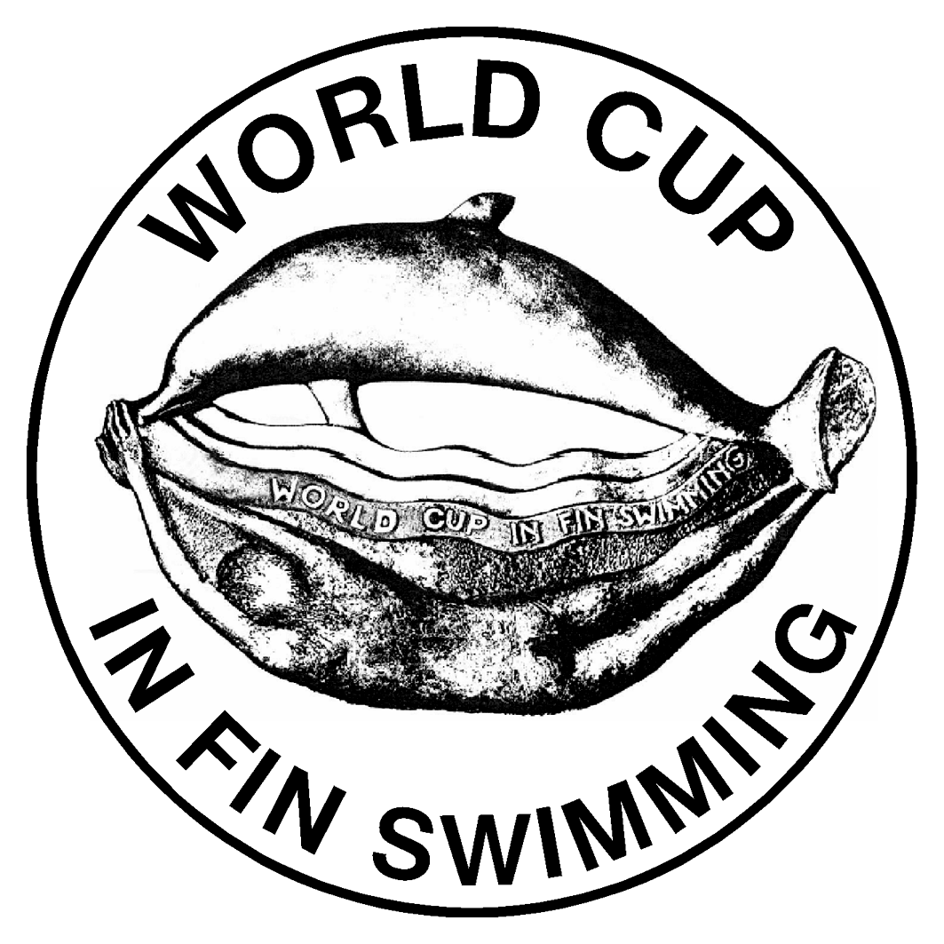

1st round
MARIBOR 2005
4th - 6th of February
http:/www.pdmb.net

1. Swimming pool
Dimensions 50X25 m, depth 2-2,2 m, 8+2 lines, water temperature 26 Celsius degrees.
Address: Indoor swimming pool PRISTAN, Koroška 33, Maribor, Slovenia

2. Time measurement
Electronic and manual.

3. Competition categories and disciplines
C cat. - age group born in 1990 and younger, boys and girls
B cat. - age group born in 1988/1989 and younger, boys and girls
A cat. - age group born in 1987 and older or younger, men and women

AP - Apnea: 50m
IM - Immersion: 100m, 400m
FS - Fin swimming: 100m, 200m,400m
Relays: 4x200m,4x100m

4. Scoring
1000 point table.
Maximum 8 competitors can start for one club.
Maximum two competitors for one club can start in one discipline/category.
One competitor can start in maximum four discipline.

5. Rewarding
The first three competitors in each discipline will receive medals, same for relays.
First three teams will receive a cup.
Best competitors in each category (man and woman) according to the 1000 point table will get the practical rewards.

6. Applications
Final applications need to be sent by post or fax, deadline 1st of February 2005.
Address: Potapljaško društvo Maribor,Koroška 33, 2000 Maribor
S L O V E N I A
fax: cod/386/2/2524934 for FURMAN Andrej
phone: cod/386/2/2282856 FURMAN Andrej
cod/386/41/756-310 FURMAN Andrej
E-mail: andrej.furman@r-kb.si
andrej.furman@h2oteam.com

Clubs without verified entry forms on Friday 4.2.2005 till 7 p.m. (19,oo) won't be entered on the start list. Verification can be made personally or per phone: cod/386/2/2296370 Dom učencev 'DRAVA' (phone – Andrej, Janny or Rebeca).

ALL ACCEPTED APPLICATIONS WE WILL CONFIRM BY E-MAIL or FAX.

7. Start fee
For each participation a starting fee of 35 EUR should be paid (30 EUR starting fee and a competition T-shirt + 5 EUR collection fee for reward on final round).
A fee of 10 EUR should be paid for each participating club.
Fees should be paid at verification.

8. Accommodation
The organiser will provide upon a request in the application board with accommodation for individual participants value of 43 EUR/two days in rooms with three beds. Accommodation starts with the supper on the 4tht of February, and ends by lunch at the 6th of February 2005.
This should be paid at the verification at arrival.
Address: DOM ZA UČENCE "DRAVA", Smetanova ulica 67, 2000 Maribor (500m from swimming pool), phone: +/386/2/2296370

The organizer can provide the transfer from airport of Brnik (Ljubljana) upon a request in the application. Transfer cost for one way 250 EUR by bus for max. 25 persons and 350 EUR by bus for max. 50 persons, for minibus (max 8 persons) 150 EUR.
This should be paid at airport or verification.

9. Protests
Protest should be submitted in a written form with a deadline of 15 minutes after
results declaration, with a fee of 30 EUR.

10. Needed documents for verification
Personal identification card or passport, and medical certification (not older than 1 year) have to be shown on verification.

11. Who may participate
All clubs could participate.

WE ARE ASKING ALL CLUBS TO BRING NATIONAL FLAG.

