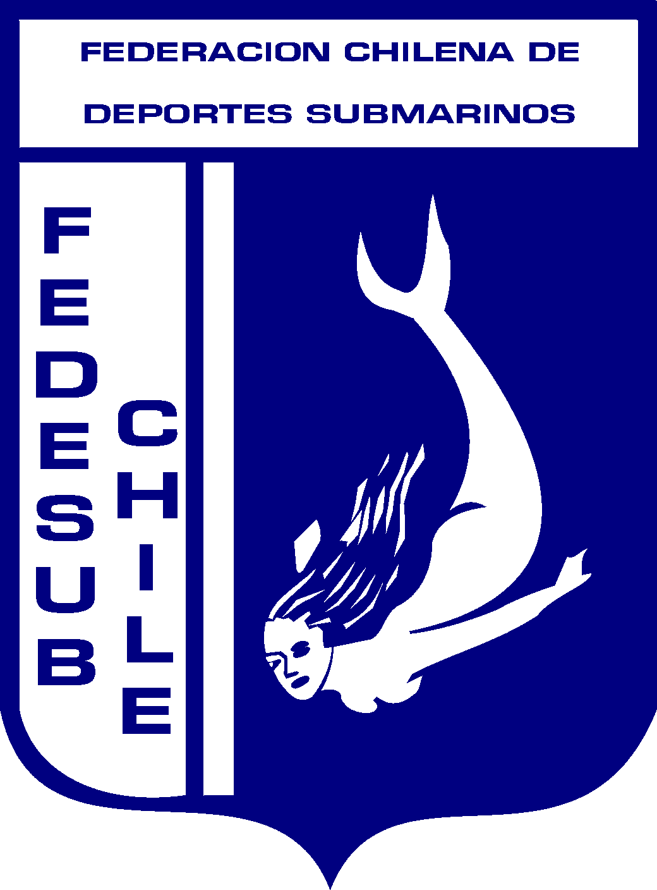

SANTIAGO, May 13 2004.

MR PRESIDENT
FEDERATION OF SUB-AQUATIC ACTIVITIES

PRESENT

Of our consideration:

The Chilean Federation of Submarine Sports is pleased to invite you and your National Selection of Submarine Fishing to the 24th World Championship of Submarine Fishing, which will take place in Iquique, Chile, from November 10 to 14 of the present year.

Attached to the present you will find the event’s Particular Regulation as well as the general bases, schedule, inscription sheet and fish listing.

For further information you can visit the web site www.fedesub.cl or send us an e-mail to fedesub@entelchile.net.

Finally, we let you know that the event’s seat is the hotel Terrado Club, e-mail: reservassuites@terrado.cl and eventosclub@terrado.cl. The alternative hotel is the Majestic, e-mail: hotelmajesticiquique@entelchile.net. By these means you will be able to contact directly with them to request rates and lodging reservations.

The delivery term of the inscription sheet expires on next June 10. This sheet may be submitted through our web site.

We welcome you to our country in advance.

p/ FEDERACION CHILENA DE
DEPORTES SUBMARINOS

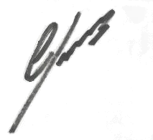
CARLOS GUTIERREZ SEGUEL
President
CGS/pgg.

OF SUBMARINE SPORTS. ALMIRANTE SIMPSON N°5 – PROVIDENCIA – SANTIAGO DE CHILE, FONO (56-2) 2220365, FAX (56-2) 2220385, E-MAIL: fedesub@entelchile.net, www.fedesub.cl

